CBES Lab

Tute-3

Q1.

An anonymous function is a [function](https://www.javascripttutorial.net/javascript-function/) without a name. An anonymous function is often not accessible after its initial creation.

In this example, the anonymous function has no name between the function keyword and parentheses ().

Because we need to call the anonymous function later, we assign the function to the show variable.

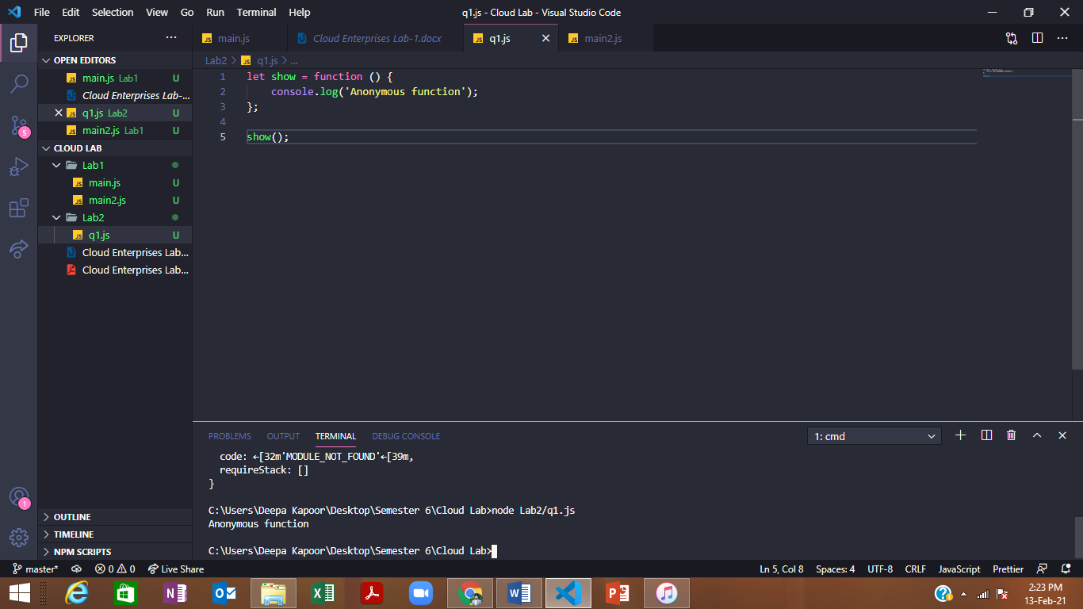

Q2.

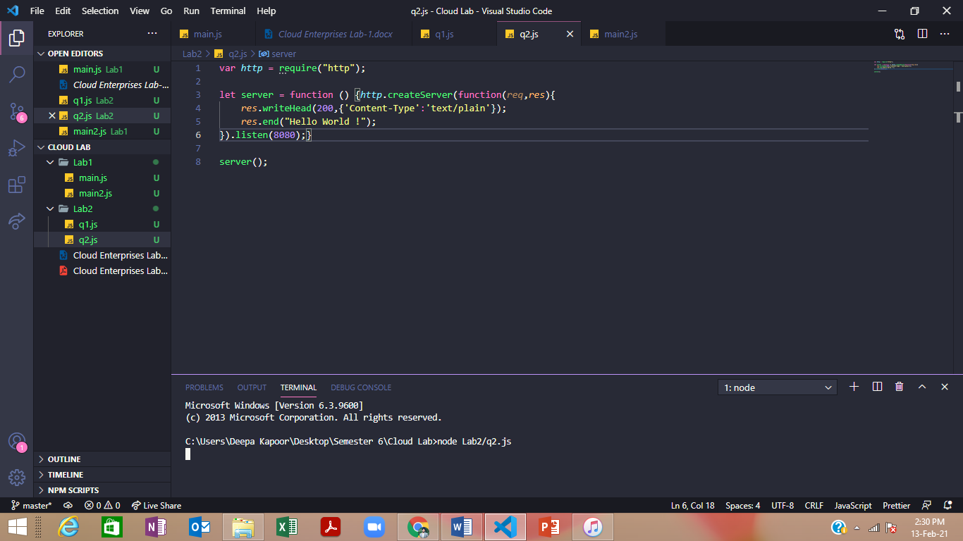

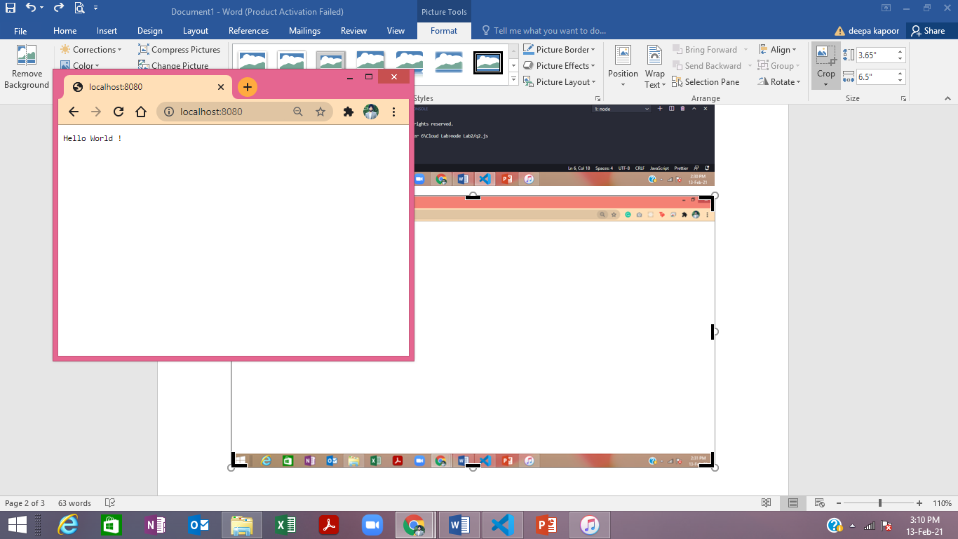

Q3.

server.js

*module*.*exports* = {

    server: function(*req*,*res*){

*res*.writeHead(200,{'Content-Type':'text/plain'});

*res*.end("Hello World !");

    }

    }

